**OOP’s Using Java Lab Programs:**

1. **Write a Java program to print the following triangle of numbers**

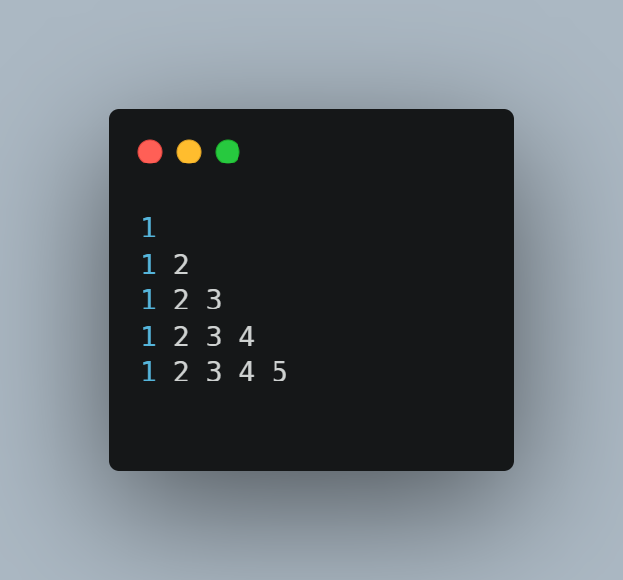

**Solution:** Using For Loop

**Note:** Convert the For Loop into while Loop and You can use any Looping For this Program.

1. **Write a Java program to list the factorial of the numbers 1 to 10. To calculate the factorial value use while loop. (Hint Fact of 4=4*3*2*1).**

**Solution-1:** Using for Loop

**Solution-2:** Using **while Loop** (Convert the for into while)

**3. Write a Java program**

* To find the **area** and **circumference** of the **circle** by accepting the radius from the user
* To accept a number and find whether the number is **Prime or not**.

**Solution:**

* **Program to Find the Area and Circumference of a Circle**:

* **Program to Check Whether a Number is Prime**:

4. **Write a Java program to demonstrate a division by zero exception.**

**

**5. Write a Java program to implement Inner class and demonstrate its Access protection.**

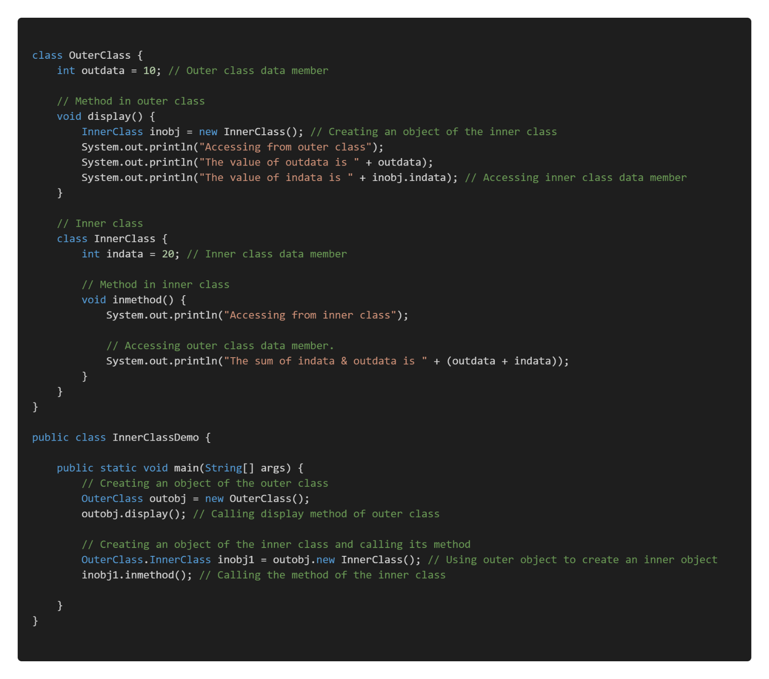

**6. Write a Java program to demonstrate Constructor Overloading and Method Overloading.**

**7. Write a JAVA program to demonstrate Inheritance. Sample Program on Java for the implementation of Multiple inheritance using interfaces to calculate the area of a rectangle and triangle.**

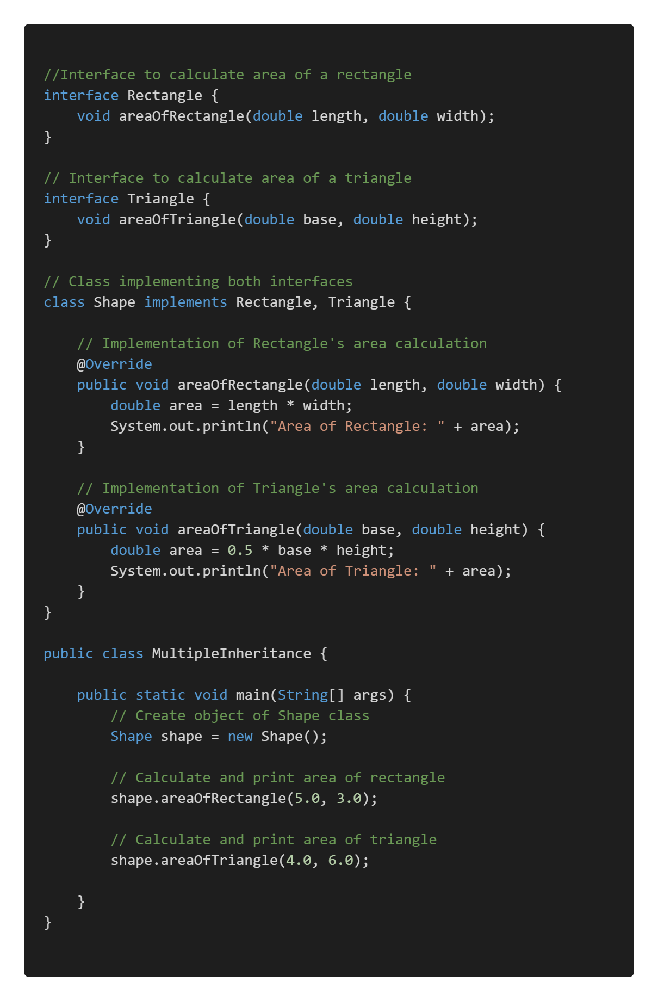

**8.** **Write a Java Applet Program, which handles keyboard event**

